CS118 Homework 2

Bolun Hu 104056403

Problem 1

1. False
2. True
3. False
4. False
5. False

Problem 2

I would use UDP. With UDP, the transaction can be completed in one roundtrip time (RTT) the client sends the transaction request into a UDP socket, and the server sends the reply back to the client's UDP socket. With TCP, a minimum of two RTTs are needed one to setup the TCP connection, and another for the client to send the request, and for the server to send back the reply.

Problem 3

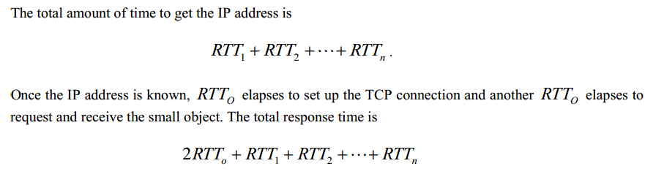

Problem 4

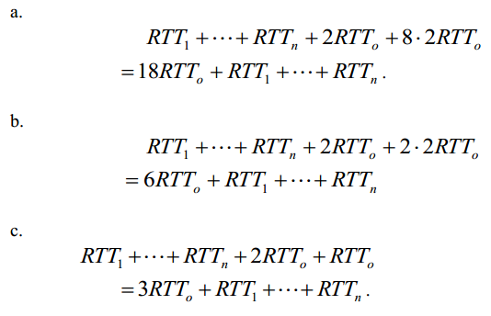

Problem 5

